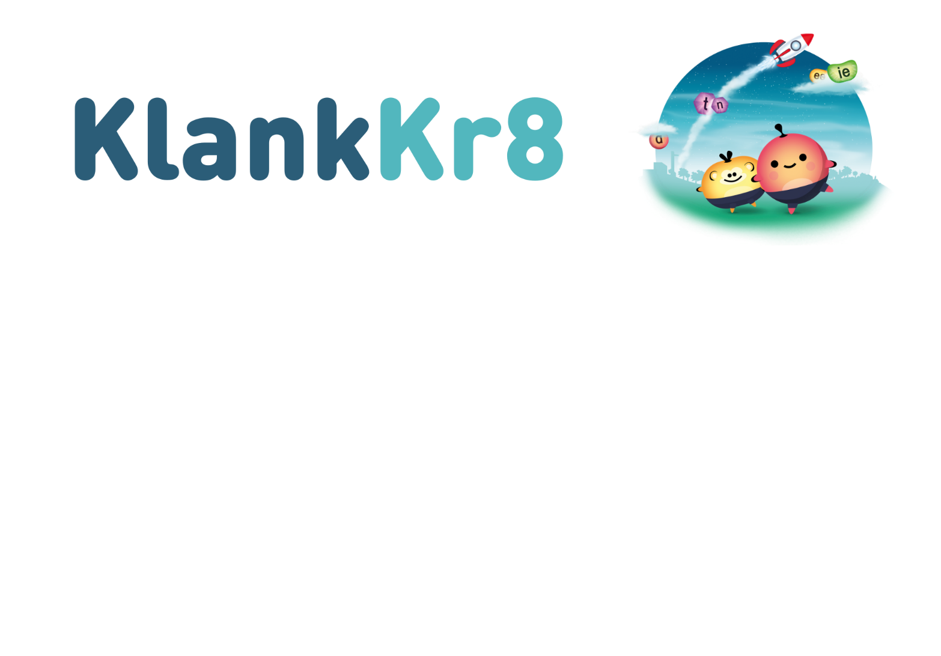

Utrecht, 18 October 2023

Subject: Participation in the KlankKr8 study

Dear parent(s)/guardian(s),

Your child's school will be working with KlankKr8 in Group 2. Klankkr8 is a programme for learning the alphabet. The programme consists of several direct-instruction classes, after which children work independently with an app.

Research firm Oberon is researching the effect of KlankKr8 together with the University of Utrecht and the University of Twente. The study is funded by the Netherlands Initiative for Education Research (NRO). The purpose of the study is to determine whether the KlankKr8 programme affects children's preparation for learning to read in Group 2 and beginning technical reading in Group 3.

This letter provides more information on the study, the data we collect and how the study is conducted. We also ask for your permission for your child to participate in the study. This means that you consent to the school sharing your child's data with researchers.

How will the research be conducted?
In this study, we compare two groups of children: one group working with KlankKr8 for about four months and one group following the normal classroom curriculum during the same period. Your child's school will be randomly assigned to one of the two groups.

Several short tests will be administered before and after the four months to assess the children's initial situation and progress. The tests involve:
- alphabet knowledge
- naming speed
- vocabulary
- listening comprehension
- letter sound recognition
A school staff member (e.g., teacher, teaching assistant, intern) will administer these tests to the children. Some of the tests are administered to the whole classroom, and some are taken individually. All tests are administered at school.

We will request the test data from the Group 3 tests from the school's student monitoring system in the middle and end of Group 3. The data concerned includes technical reading, spelling and arithmetic/mathematics. No additional tests are administered for this purpose.

In addition to the information from the tests, we also request information from the teacher about the school and your child. This includes the language your child speaks at home, how the teacher perceives the children's work ethic in the classroom and what the language lessons in school are like.

What does participation in this study mean for your child?
If your child participates in this study, they will be given a series of tests twice. The tests will take a maximum of 1 hour in January 2024 and about 20 minutes in June 2024.

Please note:
- We use the information we collect to see if the KlankKr8 app works. We do not use the information to monitor your child's development. We will not use your child's name in the study.
- The burden on your child is minimal: the tests are child-friendly, and a conscious decision was made to have them administered by someone from school whom your child is familiar with.
- We will publish the results of the survey to show how education can be improved. The results always relate to all the children participating in the study, never just your child.

What do you do if you don't want your child to participate or wish to end their participation?
You decide whether to permit your child to participate in the study. Participation is voluntary. Your child will not experience any negative effects from not participating. If you decide not to allow your child to participate, please complete the form and inform your child's teacher. You do not need to give a reason. If you decide to allow your child to participate, you can withdraw your consent again at any time, even during the study. You can inform the teacher in this case.

When will the study end?
Your child's participation in the study will end at the end of the 2024–2025 school year or if you withdraw your consent for their participation earlier. The entire study will be complete when all data has been collected and examined from all participating children.

What will happen to the data?
All data collected within this study will be anonymised. This means that the researchers examining the data no longer know which data belongs to which child. However, for the organisation of the study, we need to know which children are participating. The names will be stored in a secure location that is only accessible to the researchers involved in the organisation. Upon completion of the study, the names of participating children will be removed.

If your child participates in the study, we will provide the anonymous data to the NRO. The data is reported by code, never by name or address. We also report anonymously in research reports. The anonymous data from the study will be kept for ten years after the study ends.

Has this study been approved?
The funding provider, the NRO, has approved the research plan and data processing and storage methods. The University of Twente's ethics committee also issued a positive opinion on the execution of this study.

How do you consent?
We need written permission from parent(s)/guardian(s). We hope you will find the KlankKr8 study as important as your child's school does and consent to your child's participation. To do so, please complete the form and hand it to your child's teacher. Thank you in advance for your cooperation in this study.

Sincerely, on behalf of the entire KlankKr8 research team,

Anniek van den Hurk, MSc., Oberon
Suzanne Gerritsen, MSc., Oberon

Questions
If you have any questions about the study, please contact the researchers at onderzoekklankkr8@oberon.eu.
If you have any complaints about the study, please contact Mr Van der Lubbe (r.h.j.vanderlubbe@utwente.nl).

https://www.rid.nl/onderwijs/klankkr8
https://www.nro.nl/onderzoeksprogrammas/effectmeting-kansrijke-interventies-po-vo

